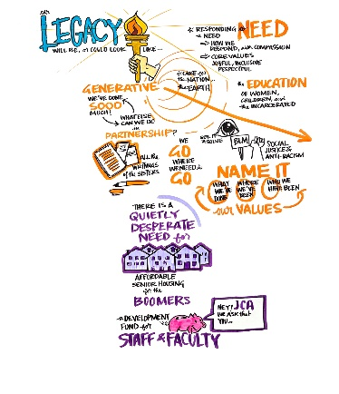
Response Sheet

Dear Convener, after your discussion in your Local Chapter, please formulate your collective response to the following questions:
- How do you view generosity and generativity through a Franciscan lens?

- What is one topic that you would like to suggest we all talk about this summer as we prepare for Chapter in 2027?

Please return this sheet to René Simonelic by Friday, May 1, 2026.
Email to rsimonelic@jolietfranciscans.org / or mail to 1433 Essington Road, Joliet, IL 60435
Thank you so very much!

